**Name : Utkarsha Avirat Sutar**

**PRN : 21520004**

**Batch : T5**

**Subject : Software Engineering Tools Lab**

**Assignment 3 : Study of Project Management Tool (Jira)**

1. **Create a project (give name of your project) in Jira, use template as Scrum and add your team members into this project.**

1. **Create an Epic into above project (main requirement of your project, e.g Creating a web application for student result generation).**

1. **Create at least 5 user stories with respect to above epic for your project.**

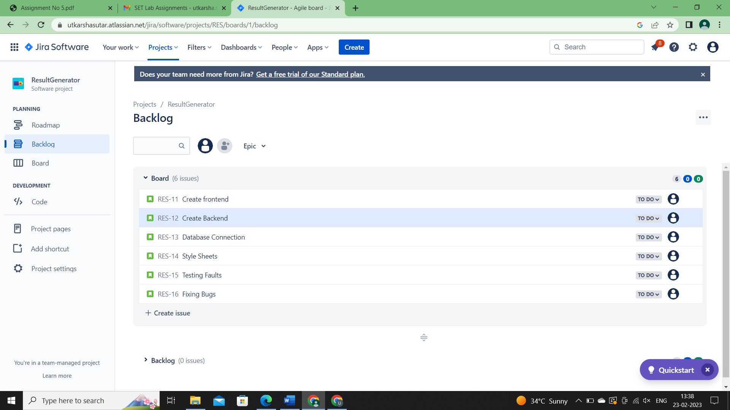

1. **Create at least 2 subtasks for every user story. Assign user stories to your team members.**

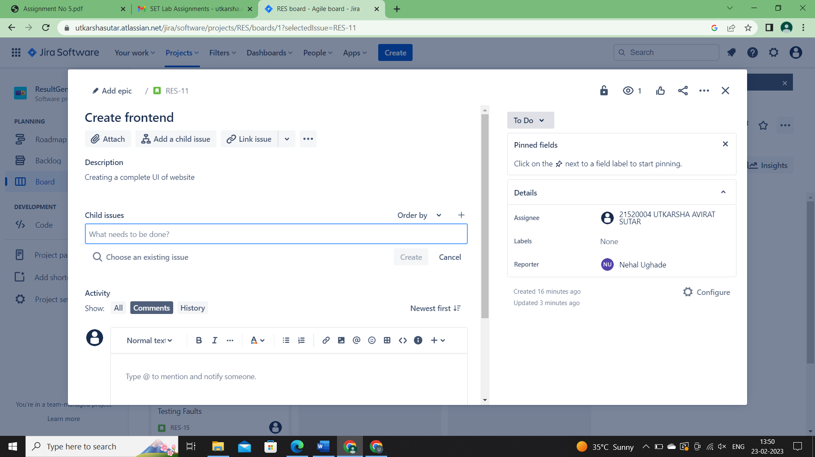

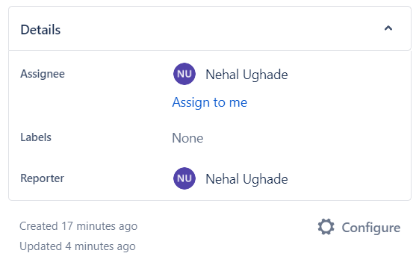

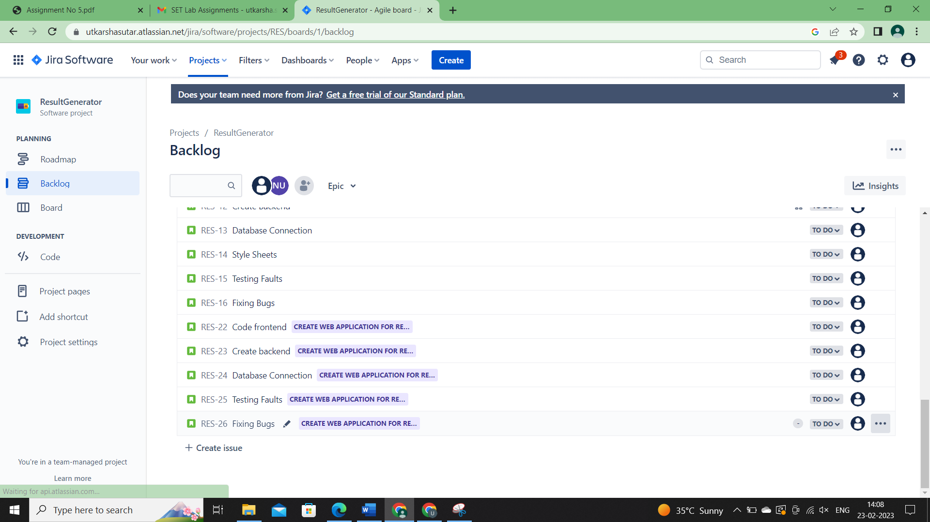

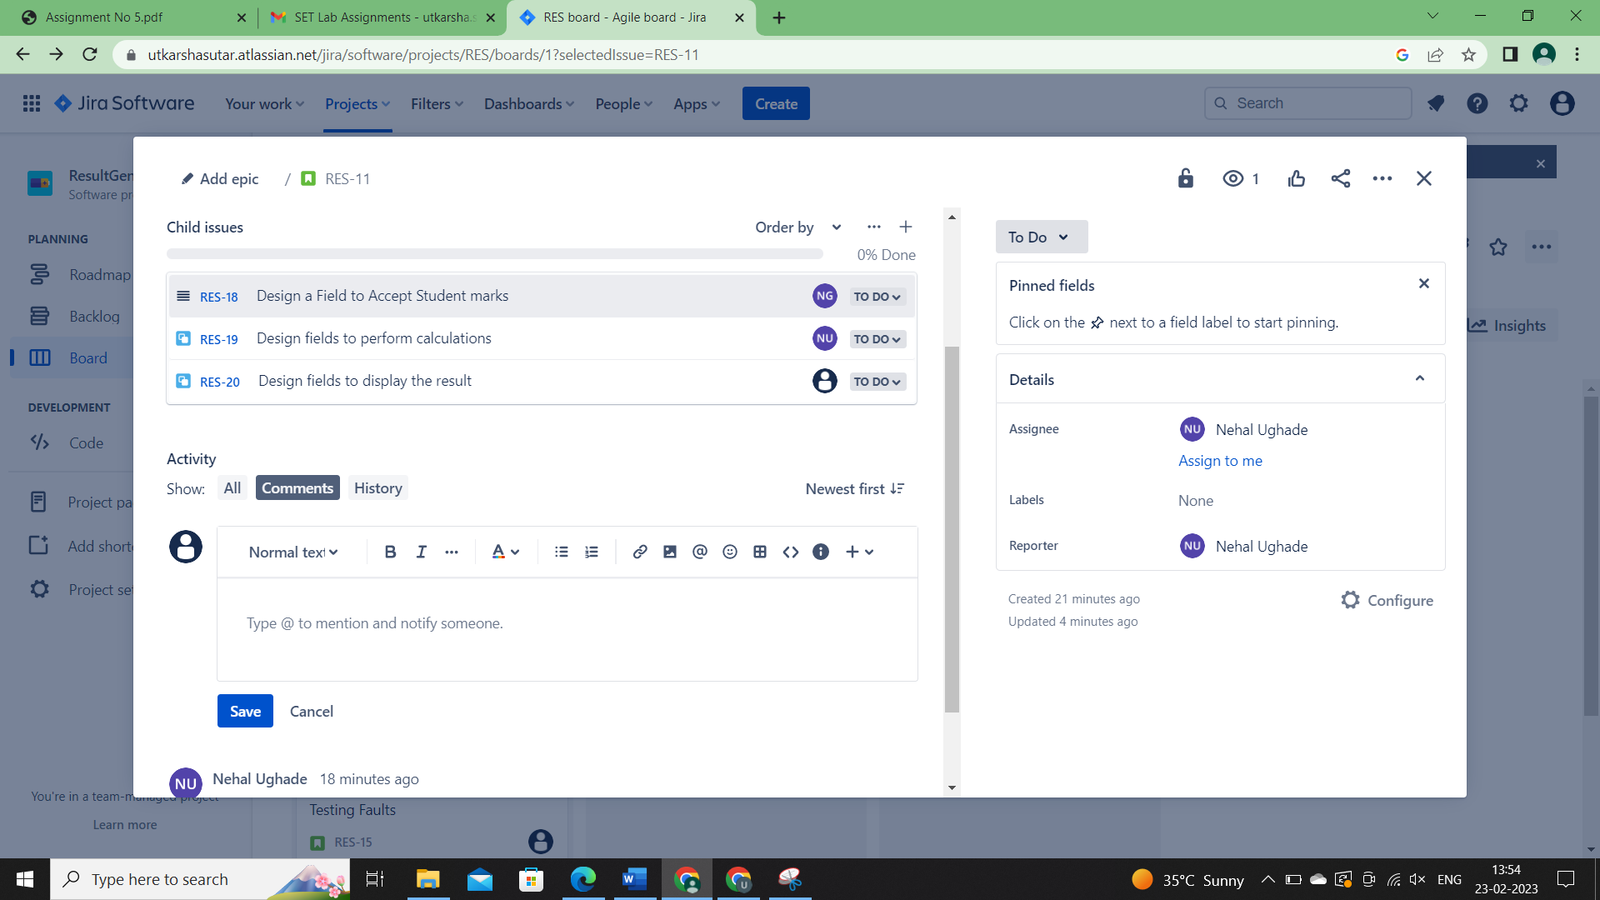

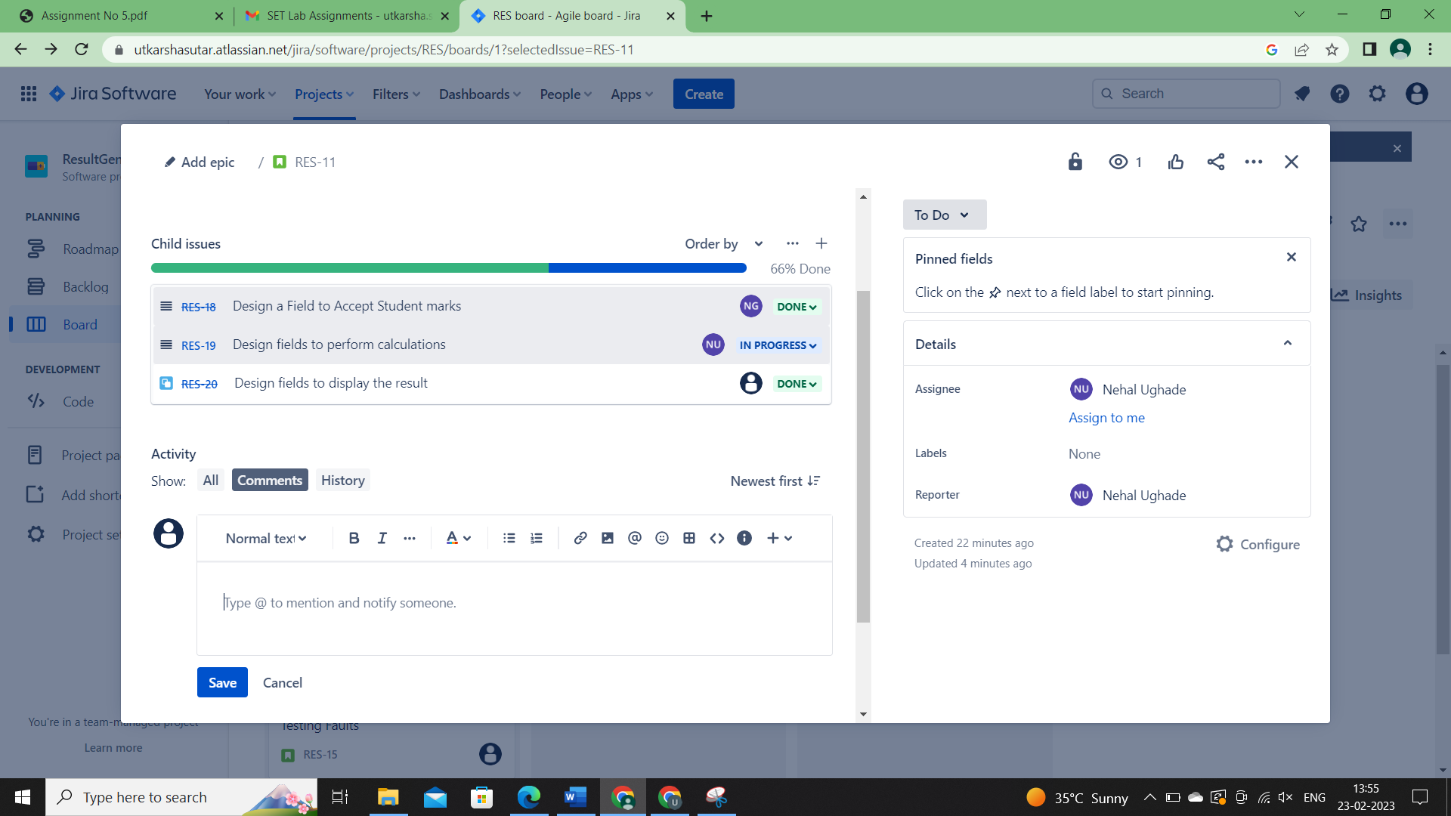

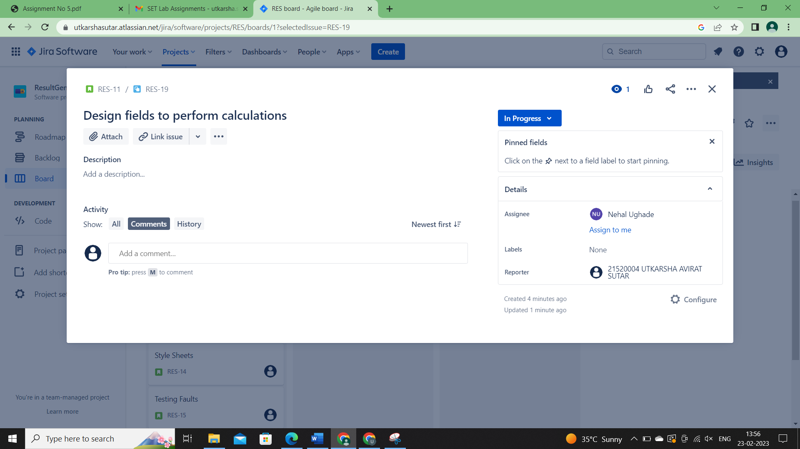

1. **Create sprints for every use stories and prioritize them according to your tasks. Assign time period for every user story.**

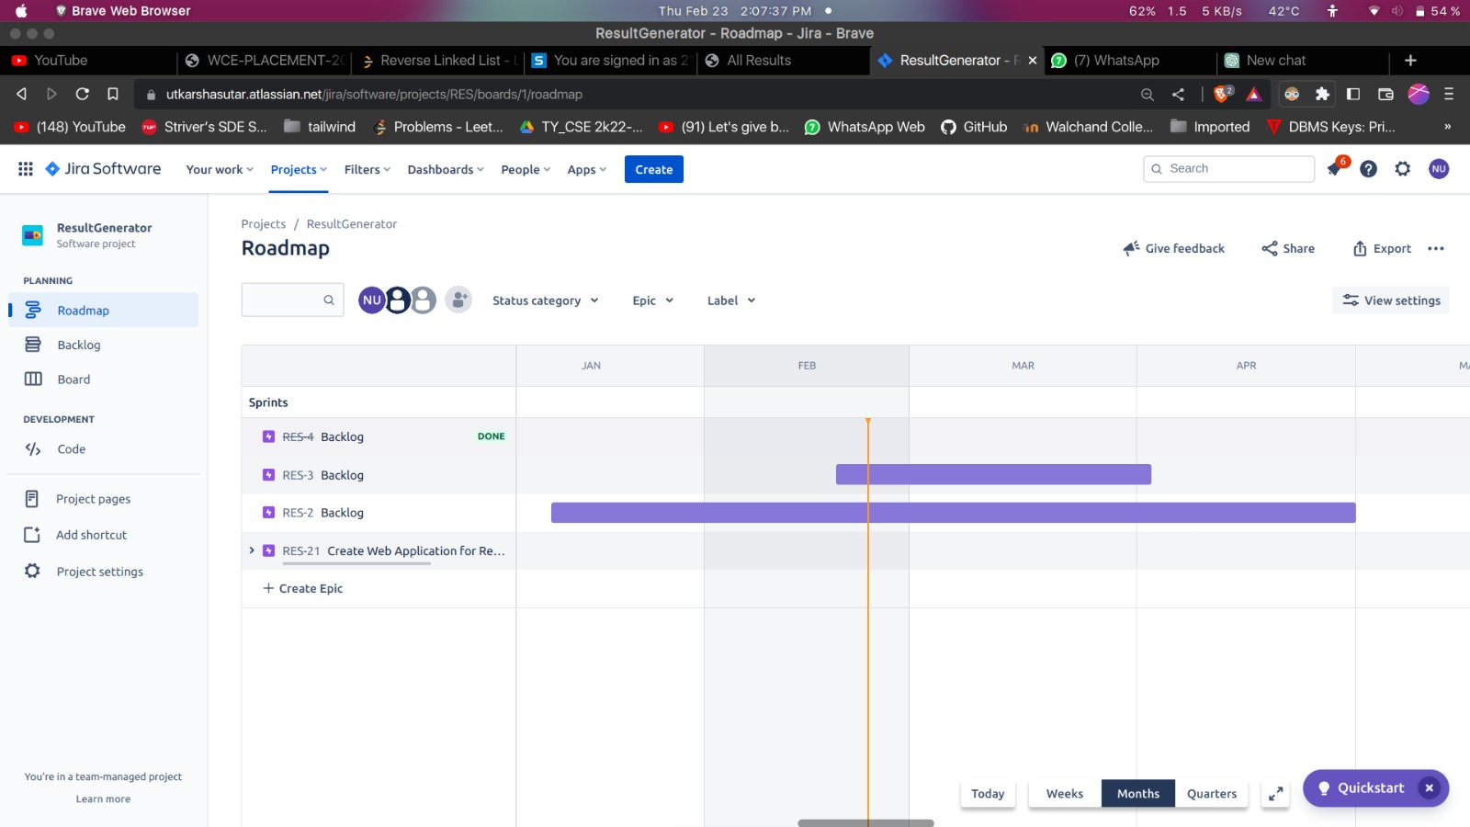

1. **Update the status of some user stories as To Do, In Progress or Completed according to sprints (add appropriate comments).**

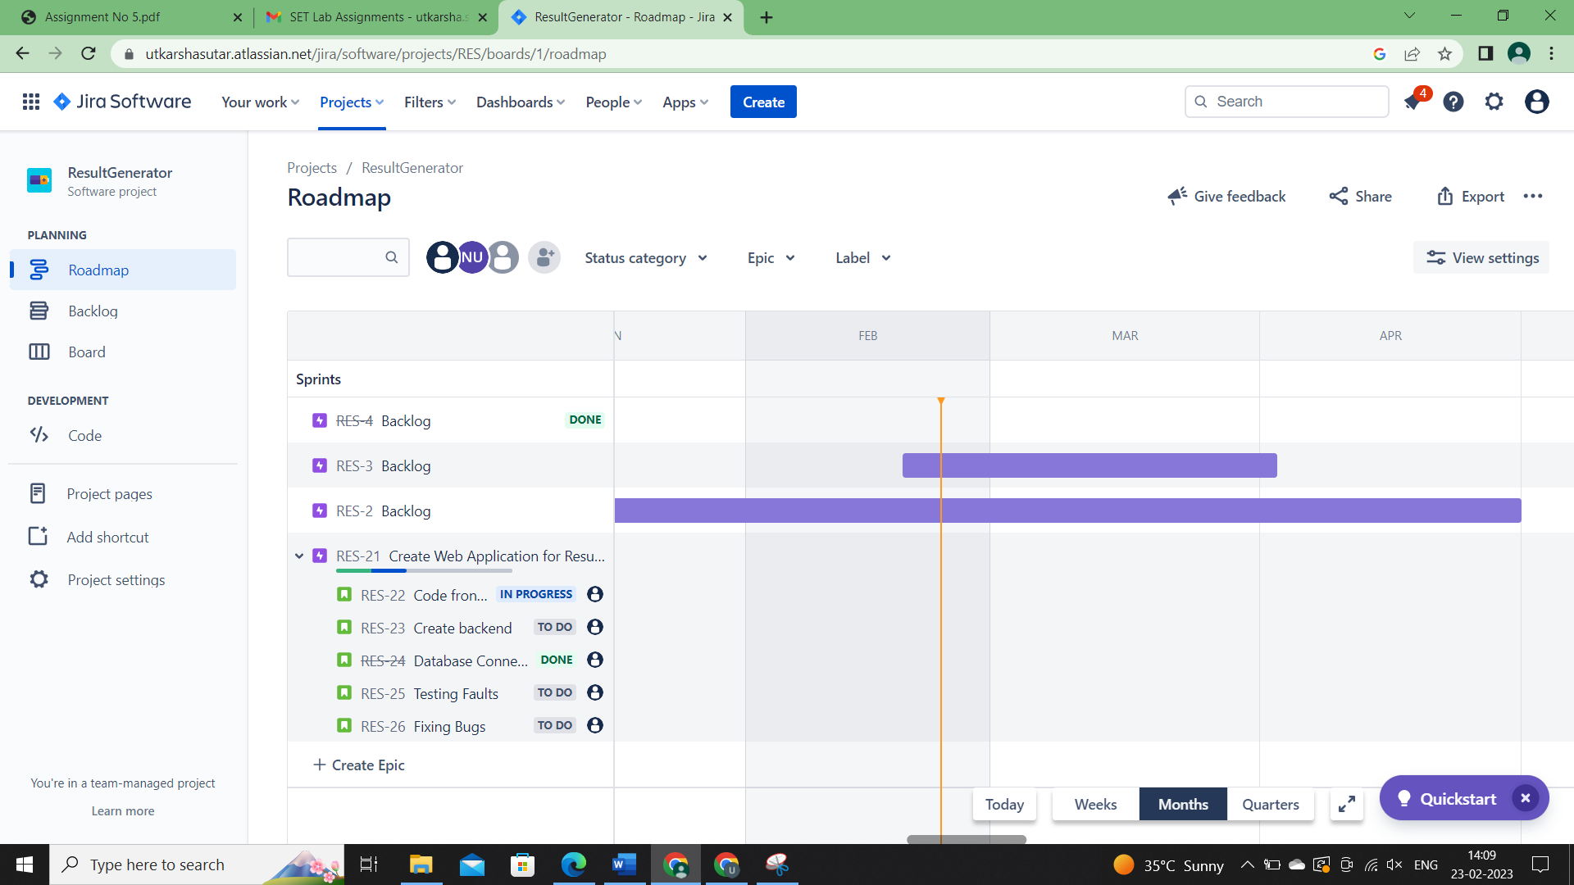

1. **Create a bug/issue for respective user story and epic and assign to respective member.**



1. **Display reports (Burnup chart, Burndown chart) w.r.t your created project.**

